
https://atlas.cid.harvard.edu/

Optimal Industry Development Strategy Using Economic and Product Complexity

Japan

─
The Economic Complexity Lab - Columbia University
Haoxian Chen, Davepriyan Gunaratnam, Rohan Macherla, Ajit Akole, Shomik Ghose, Alex Wei-Liang Ku, Sannidhya Modi, Xilin Wang, Alexandra Garcia, Kelly Mi, Alex Chung, Margarita Demkina
Optimal Industry Development Strategy for Japan

0. Executive Summary

In this report, we aim to uncover the economic path Japan went through during the period from 2013 to 2018. We include an additional analysis regarding the impact of COVID-19 on the country’s development in 2021. Specifically, we dive into the topic through a macroeconomic overview of Japan from the perspective of Gross Domestic Product (GDP) and Economic Complexity Index (ECI), which reflect countries’ production capability and production structure, respectively. We find that between 2013 and 2018, Japan demonstrated a low level of economic growth with an average annual GDP growth rate of -3.2%, concurrent with a stagnation in economic complexity as compared with other major economies in Asia. Average annual GDP growth increased slightly to -1.22% between 2019 to 2021, but economic complexity decreased, again in line with other developing economies.

The lack of economic progress during the period, we believe, can be partially explained through analysis of the economic and product complexity structure of Japan on the industry group level. The product classification system we adopt allows us to measure the realized industry development for various industry groups and to observe that Japan aggressively invested in Transportation, Weapons and Wood Products industry groups during the period, while its developed peers and emerging economies around the globe have adopted a slightly more conservative growth path. Regarding the post-COVID decline in economic complexity coupled with a negative GDP rate as observed in 2021, we determine that Japan prioritized basic, low complexity industries such as Transportation and Precious Stones in reaction to the lower global demand for higher complexity products.

Based on our analysis of the opportunity gain and a sensitivity analysis of major industry groups, Japan can further its gains by developing Textiles and Precious Stones. We further note that Japan has a slightly mismatched development strategy that indicates a moderate level of structural optimality on the complexity level, having an adjusted R-square of around -4.8% in 2018. However, in 2021, adjusted R-square is 0.16% as the gap between realized industry development and potential opportunity gain in the aforementioned and other industries is reduced. Since a significant positive correlation exists between five-year GDP growth and the structural optimality index of an economy as we define and calculate, Japan indeed has a greater annual GDP growth in 2021, but has suboptimal growth as compared with fast-growing economies both on a regional scale and on a global scale, and has the potential to further its economic gains through industrial structure balancing as suggested in the paper.

1. Report Overview

In this report, we aim to uncover the economic path Japan went through during the period from 2013 to 2018, and the impact of COVID-19 on its economic development as observed in 2021. Specifically, we dive into the topic through a macroeconomic overview of Japan from the perspective of Gross Domestic Product (GDP) and Economic Complexity Index (ECI), which reflect countries’ production capability and production structure, respectively. We then analyze the industrial framework and changes of Japan during the period based on quantitative measures such as Product Complexity Index (PCI) and Product Family Complexity Index (PfCI), followed by a detailed analysis of how such changes have matched with development strategies as quantitatively measured by opportunity gains on an industry-level. We conclude our report with macro-level results and predictions of Japan, as deduced from regression models we have established on a global scale, which take into account countries’ stances in their product space.

2. Macroeconomic Results

2.1 GDP Ranking and Changes
As the 3rd largest economy in the world by GDP, Japan has a GDP of 5.2 trillion USD in 2013 and 5.0 trillion USD in 2018, exhibiting an extraordinary level of economic output. Figure 1 illustrates the time-series GDP results for world’s leading economies from 1999-2018, and Japan ranks among its counterparts as a stable player. Japan exhibits a consistent level of economic growth during the six years from 2013 to 2018, but during this period, Japan has an annual GDP growth rate of -3.2%. This rate is clearly below the annual growth rate of the group of leading economies in the world, which have a geometric average growth rate of 2.2% and an arithmetic average growth rates of 2.4%. The annual growth rate of -1.5% is particularly in sharp contrast to an annual growth rate of 8.2% for China, one of Japan’s major competitors in the market. The stagnated economic growth in Japan, we believe, can be reflected through consistent ECI and PCI, and can be further explained by a mismatched set of production strategies Japan adopted during the period, which we will expand at the later stage of the report.

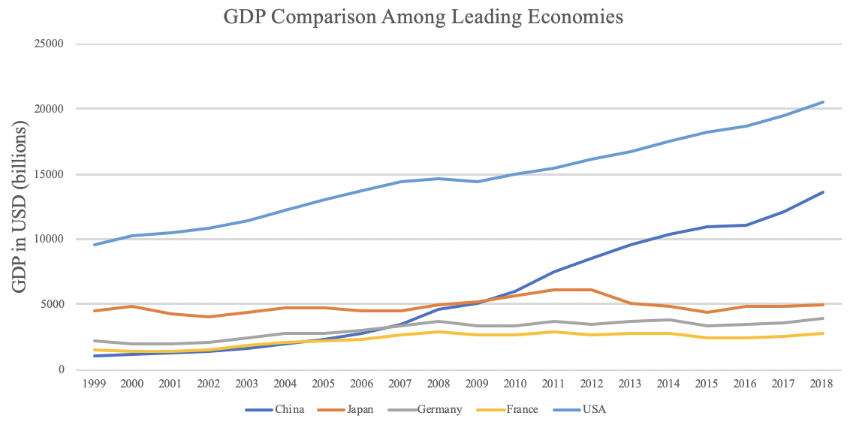
Figure 1: GDP Comparison Among Leading Economies (1999-2018)

Figure 2 illustrates the time-series GDP results in 2019-2021. In this narrower time frame, Japan, similar to Germany and France, also exhibits a steady level of economic growth, although it lags behind that of the US and China. While the US and China recorded more significant decreases in GDP due to the COVID-19 pandemic in 2020, Japan maintained a consistent GDP. However, Japan fails to keep pace with the former 2 and other highly developed countries in terms of average growth rate in a longer period of time.

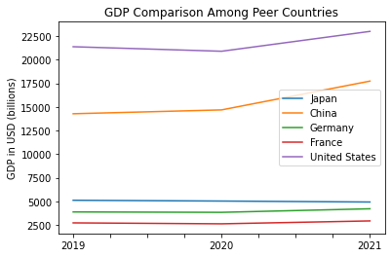
Figure 2: GDP Comparison Among Peer Countries (2019-2021)

2.2 ECI Ranking and Changes
The Economic Complexity Index (ECI), as defined by Ricardo Hausmann and Cesar Hidalgo in 2009 to explain the knowledge accumulated in a country's population, exhibits a similar pattern for Japan. As illustrated in Figure 3 below, Japan exhibits a stable but flat curve in terms of its production capability from 2013 to 2018, which is true for most of the developed economies. This is in direct contrast to countries such as China, which demonstrates overwhelming advantage over Japan in terms of both ECI and GDP growth during the period.

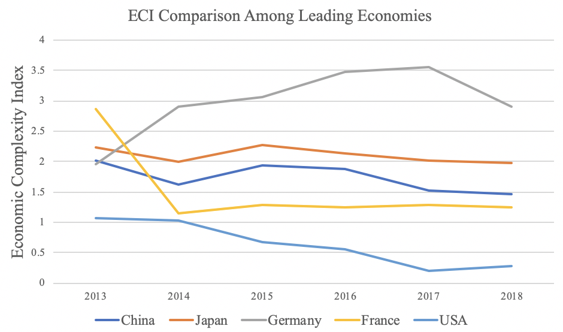
Figure 3: ECI Comparison (2013-2018)
However, as shown in Figure 4, Japan exhibits a significant decrease in production capability from 2019 to 2021. Its peers also experienced comparable decreases in production capability over the period, as marked by a sharp decline following 2020.

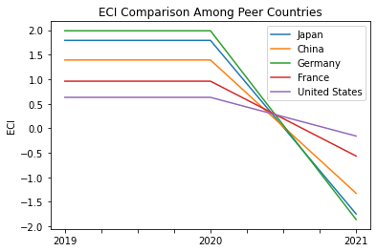
Figure 4: ECI comparison (2019-2021)

Figure 5 offers a further comparison of GDP and ECI over the entire time span from 2013 to 2018 for Japan. The stagnancy in GDP during the period from 2013 to 2018 is accompanied by a stagnancy in ECI, indicting the potential that the mild economic growth experienced by Japan during the period from 2013 to 2018 might be attributed to its slow-growing ECI, or the ineffectiveness of the country in developing a competitive product space that helps to accumulate complicated knowledge and technology. In order to provide a more concrete answer to why this has happened, we will dive into an analysis of Japan’s production structure and its product space designs in the next few chapters.

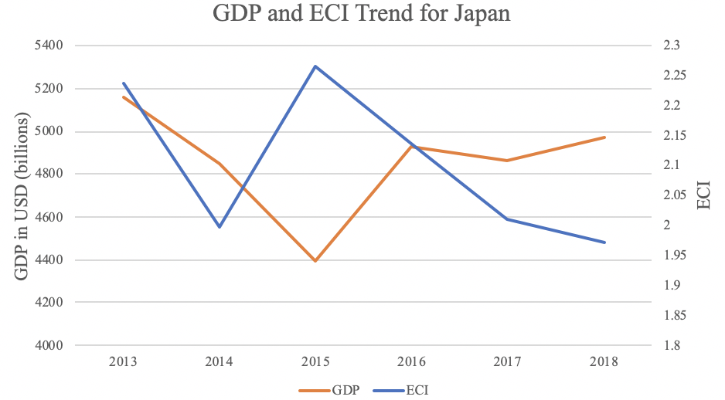

Figure 5: GDP Growth and ECI of Japan (2013-2018)

Figure 6 compares GDP Growth and ECI between 2019 and 2021 for Japan. The decrease in GDP growth during the period from 2019 to 2021 is paralleled by similar changes in ECI. The COVID-19 pandemic, and subsequent lockdowns, in 2020 restricted many industries, as demonstrated in the lower ECI, which further exasperated the decrease in GDP.
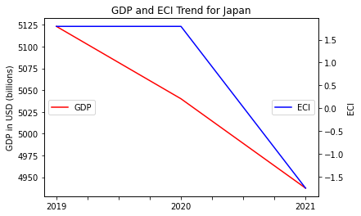
Figure 6: GDP Growth and ECI of Japan (2019-2021)

3. Production Analysis

3.1 Product Categorization
Our main data source in this research is the UN Comtrade Website (https://comtrade.un.org), which provides us with valuable information on countries’ export values on an annual basis, including highly specific export data for more than 5000 categories of products. In order to have a holistic vision of the product space of a country, however, a level of categorization is required. Products in our data source are labeled from 010000-999999, with the first two-digits representing a general category to which the product belongs. Based on the 99 categories as extracted from the label, we further group the products into 18 most widely-accepted industries, as summarized in Table 1.

Note that the High-complexity Products industry group is not a distinct industry but rather an aggregated industry that encompasses the most complicated products from the most technologically-advanced industries (as measured by PCI). This industry serves as an indicator for us to quantitatively evaluate how well a country has performed in developing cutting-edge technologies and closing its technical gap with advanced economies, which has become a topic of wide concern today. Indeed, when we rank the 18 categories based on PfCI (an equivalent concept of PCI as calculated based on the 18 categorized product groups), the High-complexity Products industry has the highest PfCI among all industry groups.

Category | Description
Animals and By-products | All kinds of meat, livestock and related by-products
Vegetables, Fruits and Plants | All kinds of plants, edible vegetables and fruits
Food and Preparations | Edible preparations, raw cooking materials and appliances
Clothing and Accessories | All kinds of fabrics, filament, clothing and accessories
Textiles | All kinds of textile articles and related products
Wood Products | Book, paper and other elementary products related to wood
Metals | Mining of all sorts of raw Metals
Refined and Processed Stones | Refined or processed stone products such as pearl and ceramics
Energy Drilling and Mining | Mining industry for energy, minerals, stone materials, etc.
Daily Instruments | Basic daily instruments such as sport requisites, timing and measuring tools
Raw Manufacturing | Basic products made from plastic, rubber, leather, etc.
Chemical Manufacturing | Advanced chemical products and pharmaceutical products
Chemicals | Raw chemical materials and by-products
Machinery and Construction | Machinery and mechanical appliances, including electrical equipment
Transportation | Vehicles and locomotives including aircraft, ship, railway, etc.
Weapons | Explosives, arms and ammunition
Services and Utilities | Financial, business, legal, communication, travel Services and Utilities, etc.
High-complexity Products | Agglomeration of advanced products with highest PCIs

Table 1: Categorization of Products

We further observe a positive correlation between the GDP and the export of High-complexity Products. A higher adjusted R-square exists between GDP and High-complexity Products exports, indicating that more successful economics, as measured by GDP, tend to be those that are capable of producing and exporting High-complexity Products as we define them. The Figures 3 and 4 show the OLS results in a universe of 137 and 21 typical countries respectively.

 | High-complexity Products | Food and Preparations | Animals and By-products
Adj.R-squared | 0.604 | 0.006 | 0.002
F-statistic | 9.556 | 1.638 | 1.175
No. Observations | 137 | 137 | 137

Figure 3: OLS Regression Results of GDP against Percentage Volume of Exports

 | High-complexity Products | Food and Preparations | Animals and By-products
Adj.R-squared | 0.149 | 0.003 | -0.012
F-statistic | 4.510 | 1.059 | 0.7542
No. Observations | 21 | 21 | 21

Figure 4: OLS Regression Results of GDP against Volume of Percentage Exports

3.2 Realized Industry Development
Based on the product categorization aforementioned, we aim to capture Japan’s realized industry production strategy between 2013 and 2018 on a complexity level. In Hausmann and Hidalgo (2009), distance is defined to be a measure of how far a country is from a certain product not in its product space. We extend this concept to all product groups and quantify how technically equipped a country is to develop the corresponding product groups. In other words, the shorter the distance between a country and a product group, the more capable a country is in developing products within that group. Defining this net distance change as the Realized Industry Development (RID), our export data allow us to calculate and compare RID of Japan and the 18 product groups in 2019 to 2021 through subtraction, where a positive RID indicates a shortening of the distance (i.e., advancement of the industry), and a negative RID indicates the reverse. As ranked in Table 2, during the period from 2013 to 2018, Japan has focused on products with a moderate level of complexity and those requiring intermediate skills.

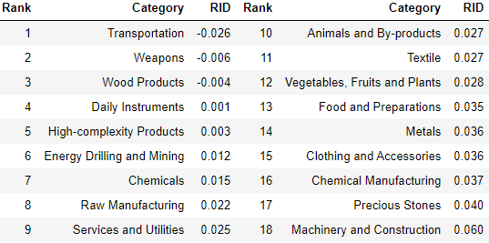
Table 2: Realized Industry Development (RID) of Japan (2018)

The most notable change between Table 2 and 3 is the ranking of Transportation, which transitions from a negative to a positive RID. This means that Japan invested heavily in transportation, however, it also advanced other lower-complexity industries, such as Energy, Drilling, and Mining and Animals and By-products. Additionally, High-complexity Products dropped to the second lowest RID in 2021, a regression from previous years.
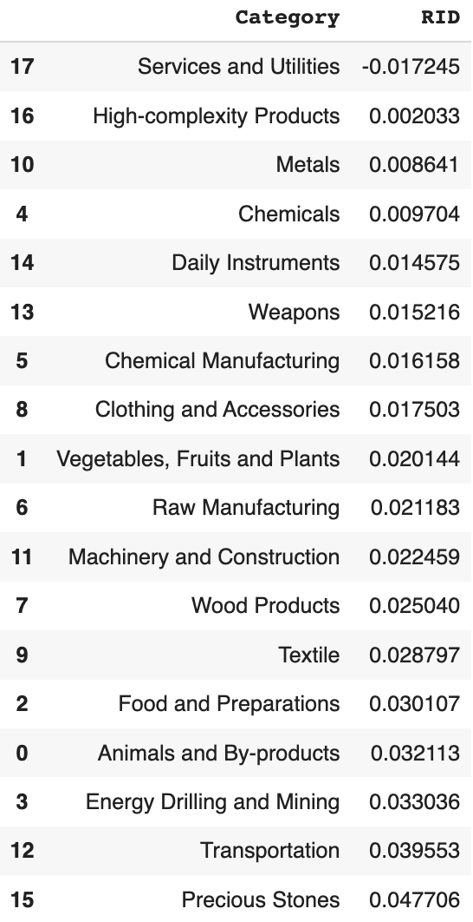
Table 3: Realized Industry Development (RID) of Japan (2021)

3.3 Regional and Global Comparison
Table 3 and 4 below summarize how the production strategy adopted by Japan compares with leading economies and a selected group of emerging economies in the world, as measured in RID. It can be directly observed that Japan focused on products with a lower complexity level, when compared against leading economies such as the United Kingdom and Germany, which gave a considerable level of attention to more advanced product groups such as daily instruments and high-complexity products.

Ranking | France | the UK | Germany
1 | High-complexity Products | Services and Utilities | High-complexity Products
2 | Chemical Manufacturing | Weapons | Transportation
3 | Daily Instruments | Raw Manufacturing | Wood Products
4 | Animals and By-products | Precious Stones | Metals
5 | Food and Preparations | Animals and By-products | Food and Preparations
Table 4a: RID Comparison across Leading Economies (2018)

Ranking | France | the UK | Germany
1 | Services and Utilities | Precious Stones | Daily Instruments
2 | Precious Stones | High-complexity Products | Transportation
3 | High-complexity Products | Services and Utilities | Chemicals
4 | Energy Drilling and Mining | Energy Drilling and Mining | Chemical Manufacturing
5 | Machinery and Construction | Wood Products | Clothing and Accessories
Table 4b: RID Comparison across Leading Economies (2021)

Ranking | China | South Korea | Singapore
1 | High-complexity Products | Transportation | Transportation
2 | Transportation | Textile | High-complexity Products
3 | Machinery and Construction | High-complexity Products | Precious Stones
4 | Energy Drilling and Mining | Chemical Manufacturing | Daily Instruments
5 | Daily Instruments | Machinery and Construction | Services and Utilities
Table 5a: RID Comparison across Emerging Economies (2018)

Ranking | China | South Korea | Singapore
1 | Chemicals | Chemicals | Weapons
2 | Daily Instruments | Daily Instruments | Energy Drilling and Mining
3 | Transportation | Transportation | Transportation
4 | Raw Manufacturing | Textile | Machinery and Construction
5 | Weapons | Raw Manufacturing | High-complexity Products
Table 5b: RID Comparison across Emerging Economies (2021)

Table 5a and 5b further examine Japan’s development strategy against those of emerging economies on a global scale. Reasonably, emerging economies such as China, South Korea, Singapore and India have devoted the majority of their efforts into intermediate industry groups while developed economies such as Japan should have relied more on advanced industry groups. This trend holds true in general, regardless of the continent or the time period, and serves as an indicator for which phase of development a country is currently in as evaluated from its production strategy. Based on this standard, Japan is indeed adopting a moderate but slightly out-of-phase strategy that seeks development in industry groups with a lower level of complexity than it should.

4. Product Space Design

4.1 Suggested Development Vector
As aforementioned, distance gives us an idea of how far each new product is from a country’s current mix of exports. As defined in Hausmann and Hidalgo (2009), distance is “the weighted proportion of products connected to goods p that country c is not exporting, i.e., MCP=0.” Based on this definition, the distance between a country and any product that the country is currently exporting (i.e., the country is a significant exporter in the product as compared to global average) is zero. Similarly, opportunity gain quantifies the contribution of a new product in terms of opening up the doors to more and more complex products. Intuitively, a product that a country is currently exporting (i.e., MCP=1) has an opportunity gain of zero. And unreasonable investment on certain product p would lead to a relative decrement in export of more profitable products, and therefore lead to a negative opportunity gain of product p. The opportunity gain is not the only estimator of a country’s level of economic development. However, among countries with comparable economics strength, those having higher ECI, or in other words, more reasonable economics structure are often in better shape.

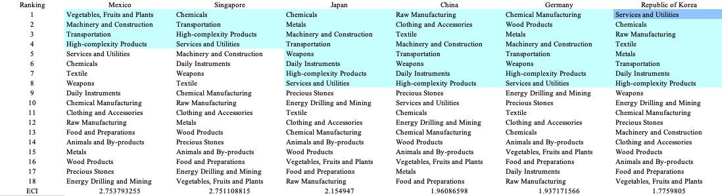

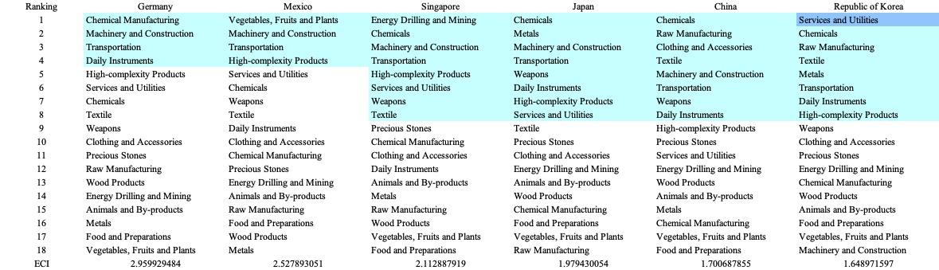
Table 6: SDV of High ECI Countries 2013(up), 2018(down)

We define the ranking of opportunity gain for a country c, as the Suggested Development Vector (SDV) of c. Table 6 shows the SDV of a selected group of leading economies with outstanding economic complexity, with the industry groups ranked in decreasing order of significance. Dark blue indicates positive opportunity gain, light blue indicates zero opportunity gains, and white indicates negative opportunity gains. The result shows that leading countries barely have any industries with positive opportunity gain. In other words, those countries are already in the most stable and efficient economic structure. Without the necessity of economic transition, those countries merely need to maintain a steady and balanced economic development. In contrast, countries listed in Table 7 have nearly half of industries with positive opportunity gain. While the economies with absolute negative E_{f}CI, such as South Africa and Japan, all need to develop High-complexity Products, Machinery and Construction and daily instruments, those with median E_{f}CI are facing a more complicated and diverse situation, such as Italy, Spain and the United States.


Table 7: SDV of Other Typical Countries 2013

It can be concluded that Japan is categorized to be a highly complex country as compared with the world’s leading economies and other major economies in Europe.

4.2 Budgeted Industry Development Strategy and Interpretation

The optimal budgeted industry development strategy aims to solve the most efficient allocations under the budgeted constraint of different situations of heuristic total export growth. In order to obtain such an allocation portfolio, we formulate an optimization problem as the following:



where k(x) is the second largest eigenvector of $M_{CC'}$ after adding $x$ to the original export vector, C is the country that we are interested in, P is the product space, B is the heuristic budget.

If we can solve this problem, then we can know what the largest ECI to which a country can improve. Accordingly, the optimal solution $x*$ that we obtain here is exactly our optimal allocation. However, the biggest problem is that the objective function is not convex. Therefore, we cannot apply the classical tools for convex optimization to this problem. In order to solve this problem, our idea is to use a greedy algorithm. The way that we apply the greedy algorithm is that firstly we separate the total budget into k equal parts, and then for the first equal part we try to search for the product that can optimize our objective function by iterating through each $p∈P$. After we find the optimal product p for this equal part, we add the amount back to the export value of this product p and update the ECI for this country. If we observe that ECI does not change after iterating all the products, then we can add up one more equal part to invest. Until we find there is an ECI increment, we add the amount now to that product. The equal rest parts can be done in the same way.

By definition, a greedy algorithm is a kind of local search algorithm, which is possible to run into a local minimum. Therefore, for local search algorithms, one typical way to keep it away from the local minimum is to enhance the vision of the algorithm by looking more steps forward. In our setting, whenever we obtain an increment of ECI, we mark down the required amount of export growth. Simultaneously, we continue searching for the next ECI increment point, compare the ratios of these two possibilities and pick the largest one. The ratio is defined as the following:


where ${ECI}_{p}$ is just the ECI of the country after adding some amount of export increment to product $p$, which is exactly the amount that is able to make ECI change. Also, we can express it in the way of $||$$x_{p}-x_{0}$${||}_{1}$.

In this way, we can obtain a further sighted greedy algorithm. Also, the number of parts that we would like to separate the budget into also matters. In order to solve this problem, we added a stabilizer on top of the enhanced greedy algorithm, by running the algorithm for different numbers of parts and selecting the portfolio with the largest ECI increment and most complex economic structure.

Besides, it is quite common that there is a surplus in the budget. To deal with the surplus, we just add it to the product which needs the least amount of dollars to make $M_{cp}$ = 1, (i.e., the smallest amount of required export increase).

Interpretation:

For the purpose of a clear explanation of the line charts, we try to label all the products in Table 9. Please refer to this table when trying to understand the investment trajectories in the line charts.

Label | Product Names
1 | Animal and By-products
2 | Vegetables, Fruits and Plants
3 | Food and Preparations
4 | Energy Drilling and Mining
5 | Chemicals
6 | Chemical Manufacturing
7 | Raw Manufacturing
8 | Wood Products
9 | Clothing and Accessories
10 | Textile
11 | Metals
12 | Machinery and Construction
13 | Transportation
14 | Weapons
15 | Daily Instruments
16 | Precious Stones
17 | High-complexity Products
18 | Services and Utilities
Table 8: Products Labeling

Below is the economic panel for Japan in 2013. We can see that for different percentages of heuristic total export growth, the ECI of Japan has different performance. From all the four line graphs, we see that Japan already obtains some great increment in terms of ECI. Also, the higher the budget is, the higher the ECI will be. This means that in terms of export, Japan still has great room to improve. For the four export growth budget, the increment primarily attributes to the development of machinery and construction, chemicals and metals. Therefore, in order to optimize ECI , Japan should focus on developing machinery and the construction industry first. Afterwards, developing the chemicals industry can also result in ECI growth.
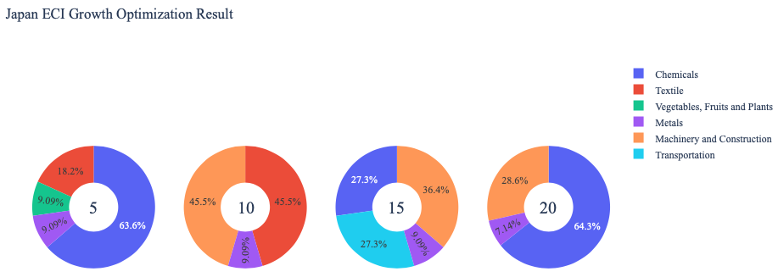

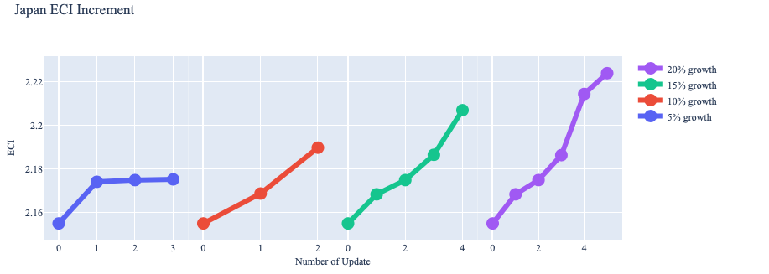

Figure 7: Greedy-Based ECI Improvement Results of Japan in 2013 with Different Budgets
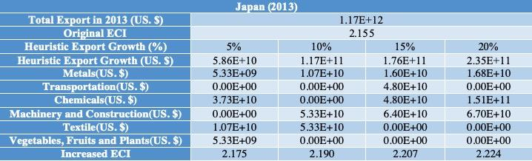
Table 9: Portfolio of Japan in 2013

For further suggestions on Japan’s development in the future, we also offer the optimization result of Japan based on export data in 2018. Below is the economic panel for Japan in 2018. We can see that for different percentages of heuristic total export growth, the ECI growth pattern of Japan is similar to the one in 2013. From all the four line graphs, we see that Japan obtains a different extent of great increment in terms of ECI. This means that in terms of export, Japan still has great room to improve. For the case of 5 and 10 percent of export growth budget, the result shows that the allocation is scattering to some fundamental industries, including animals and by-products, food, raw manufacturing etc. For the case of 15 and 20 percent of export growth budget, the result shows that growth in high-complexity products and metals can bring lots of gains in ECI. Therefore, for future strategy derived from 2018 data, Japan should prioritize development of high-complexity products, and then metal, as well as transportation etc. in order to optimize ECI.

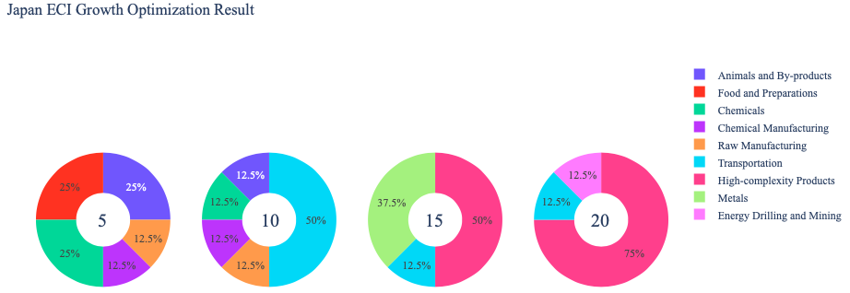
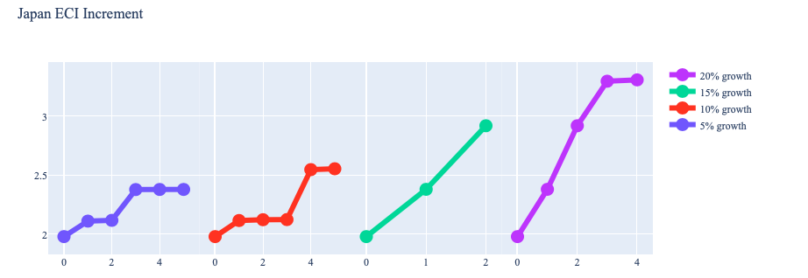
Figure 8: Greedy-Based ECI Improvement Results of Japan in 2018 with Different Budgets

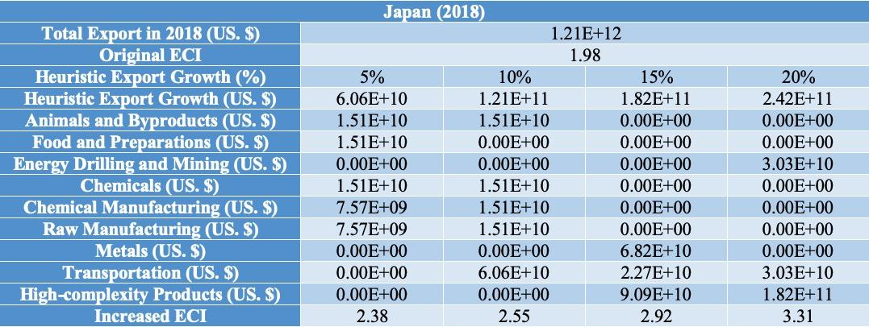
Table 10: Portfolio of Japan in 2018

Below is the economic panel for Japan in 2019. We can see that for 5%, 10%, and 20% of heuristic total export growth, the ECI of Japan has similar performances. However, from the line graphs, the 15% growth produces substantial improvement in the ECI. This is coupled with a more diverse assortment of industries, focused primarily in Machinery and Construction and High-complexity Products. This means that in terms of export, Japan has room to improve, however, it is capped at 15%. Therefore, in order to optimize ECI, Japan should focus on developing machinery and high-complexity products.
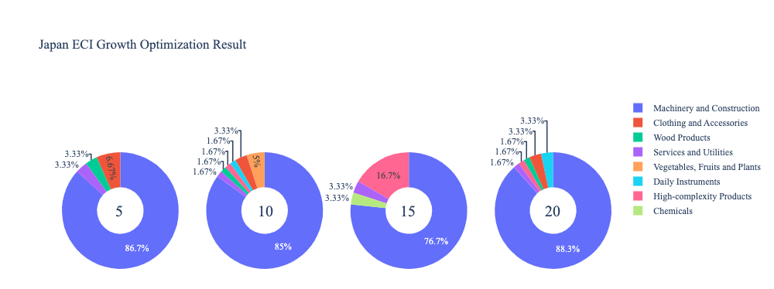
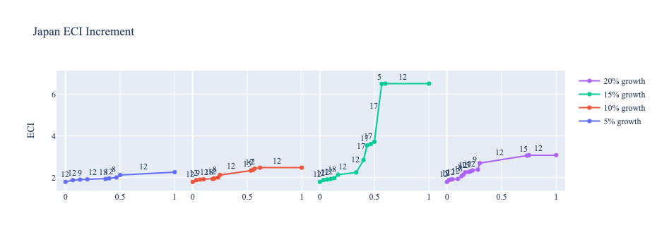
Figure 9: Greedy-Based ECI Improvement Results of Japan in 2019 with Different Budgets

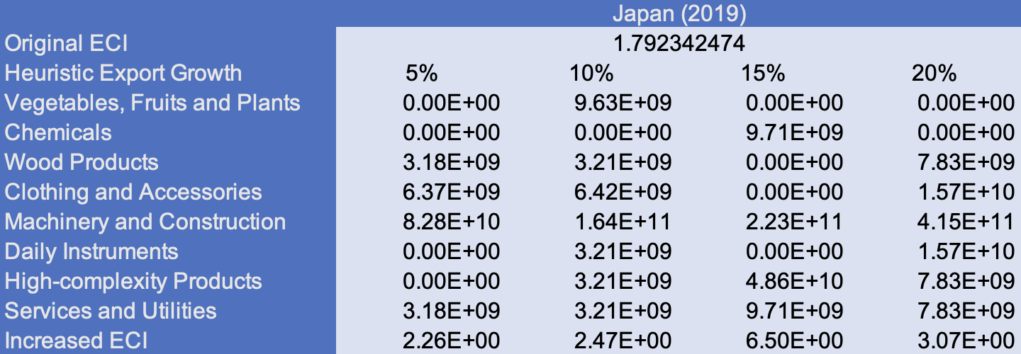
Table 11: Portfolio of Japan in 2019

For further suggestions on Japan’s development in the future, we also offer the optimization result of Japan based on export data in 2021. Below is the economic panel for Japan in 2021. We can see that for different percentages of heuristic total export growth, the ECI growth pattern of Japan is very different to the one in 2013. The assortment of industries is larger and more diverse at every single percentage, however, the assortment increases with larger percentages. At 20% of heuristic total export, the ECI also increases, but to the same amount as 15%, which means that it has greater room for improvement but is still capped. For the case of 15% of export growth budget, the result shows that growth in precious stones and textiles can bring more gains in ECI. Therefore, for future strategy derived from 2021 data, Japan should prioritize development of precious stones, and then textiles, in order to optimize ECI.
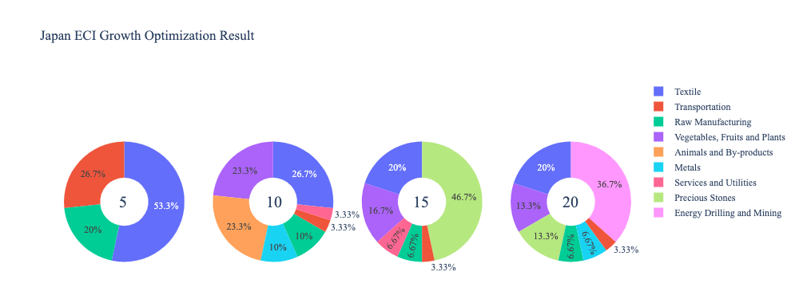
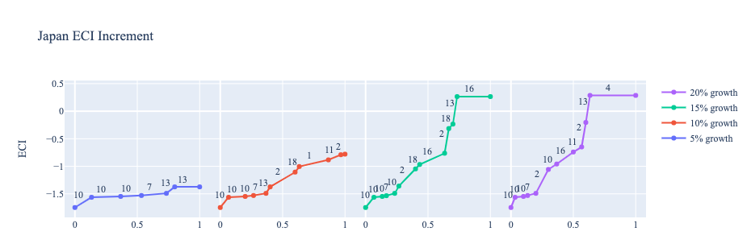
Figure 10: Greedy Based ECI Improvement Results of Japan in 2021 with Different Budgets

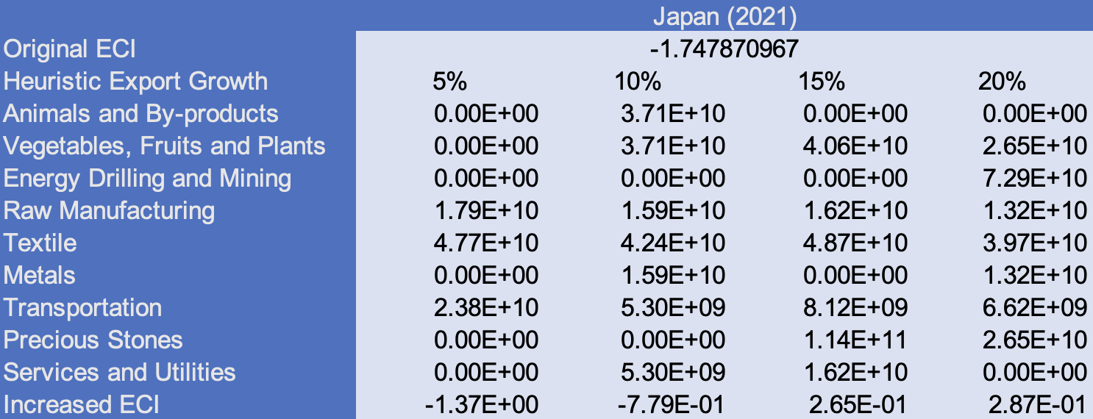

Table 12: Portfolio of Japan in 2021
4.3 Sensitivity Analysis and Contingency Strategy
In the following section our broad aim is to understand how sensitive Japan is to changes in export in various industries. While the Economic Complexity Index has been shown to contain valuable information about the economic strength/capacity of a country, little has been said as to the stability of the measure itself. We seek to uncover the main drivers of stability under a country's ECI score and better understand longer-term projections for ECI growth. Additionally, gaining an intuition on the industries that are bolstering an economy and the industries that offer the greatest return per unit of investment is best done through visualization of industry specific sensitivity. To this end, we have developed two categories of sensitivity analysis.
ECI Sensitivity Graph
Firstly, in order to assess the effect particular industries have on each respective country, we developed ECI Sensitivity graphs. We use shocking methodology to increment or decrement an industry’s export level by a certain percentage and recalculate the ECI all else being equal. While freezing the export dynamics of the rest of the world and enacting an instantaneous shock in export for a particular industry and country may not reflect real-life dynamics, what it does offer us is an understanding of a country’s level of dependency on an industry in the context of ECI. The shocking is done in small percentage increments in order to smooth out the resulting curve. Additionally, a recurring theme one will see is that for most industries, a breaking point occurs where the ECI either jumps upwards or downwards, creating a hockey stick shape rather than a linear trend. While the inflection point may not be accurate in context of real life, comparing the various inflection points across industries can give us valuable insight.
The graphs are formulated as follows: There are four ECI Sensitivity graphs. The first two represent data from 2018. The first chart shows positive shocking in which export numbers are shocked upwards per industry. The X-axis is in terms of percentage shock per current dollar value of export. The Y-axis is the recalculated ECI level post-shocking. The second chart follows the same format except the X-axis represents negative shocking. In other words, exports for each industry are decremented and the ECI is accordingly recomputed. The final two sensitivity graphs show the same results using 2013 data. Below is an example of an ECI sensitivity graph.

Figure 11: Example 2018 (Incremental ECI Sensitivity)

SDV sensitivity
Secondly, we analyze the sensitivity of the SDV to changes in export levels. The goal is to understand how export level changes for a particular industry can affect the marginal opportunity gain for other industries. We will be using specifically High Complexity Products and Food and Preparations as our base industries. We will be increasing or decreasing the absolute export level in both of these industries and observing the effects on the SDV.
When the opportunity gain of an industry is negative, the SDV sensitivity approximates how an over-development of the industry jeopardizes the economic structure of a country. When the opportunity gain of the industry is zero, the SDV sensitivity determines whether the further development of the industry shapes the country with a better economic structure and predicts how the SDV would change accordingly. Specifically, as we reduce the export of such an industry to 25%-50% of its original value, a few other industries originally with negative opportunity gain could likely become profitable.
Similar to the ECI sensitivity graphs above, we will be shocking export of High Complexity Products and Food and Preparations in small percentage increments. A new SDV, represented by a new column in the charts, is recorded only when a certain level of shock changes the structure of the SDV. In effect we are incrementing or decrementing export levels of two industries until the marginal opportunity gain of any industry changes in category (positive, negative, or neutral). Below is an example of a SDV Sensitivity chart with Positive Shocking. Industries with positive marginal opportunity gain are colored blue, neutral is colored white and negative is colored red.

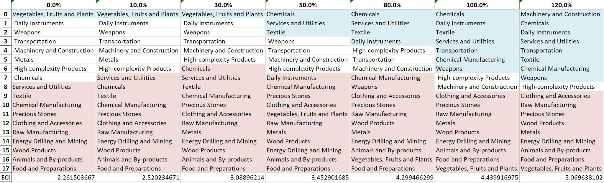
Table 13. Example High-complexity Products 2021 (Incremental SDV Sensitivity)
Contingency Plan
The Contingency Plan aims to present a set of solutions with respect to upheavals in different industries. Instead of compensating for the declining production directly, the best strategy is to develop those incipiently profitable industries. In this manner, we can derive the contingency strategy for countries to deal with possible abrupt declines of crucial industries. In some cases, the SDV remains unchanged even when a zero-opportunity-gain industry declines to its 20% in terms of export. We can then conclude the industry is not indispensable to the country. As a clarification, the three consecutive N/As means that the country doesn’t even need to respond to a collapse in the industry. Countries tend to have distinct solutions to the up and down of the same industry. To create the contingency strategy table we decrease the export level for each industry in the country’s current production space by 60% respectively. The three highest ranking industries in the new SDV are then returned.


Table 14: Example Contingency Strategy 2021

4.3 Sensitivity Analysis Results and Interpretation

Below is Japan’s 2018 ECI Sensitivity Charts. Firstly in the positive chart, we notice immediately that High Complexity Products, Transportation and Machinery give fairly significant increases in ECI. Moreover the curves seem to have a linear trend indicating that steadily increasing export value in all three of these industries can significantly improve ECI in the long term. All other industries tend to not greatly affect the ECI level making it fairly clear which industries to pursue.

Next we consider Japan’s 2018 Negative Shock chart. We can see that Japan is fairly sensitive to High Complexity Products, Transportation and Machinery. This is expected from a well-diversified, developed country. Metals, Chemical, and Weapons in particular increase ECI when exports are decreased. It may be beneficial to reduce the export level on these products and focus on some of the industries that give rise to the linear uptrend of ECI as seen in the positive shock chart.
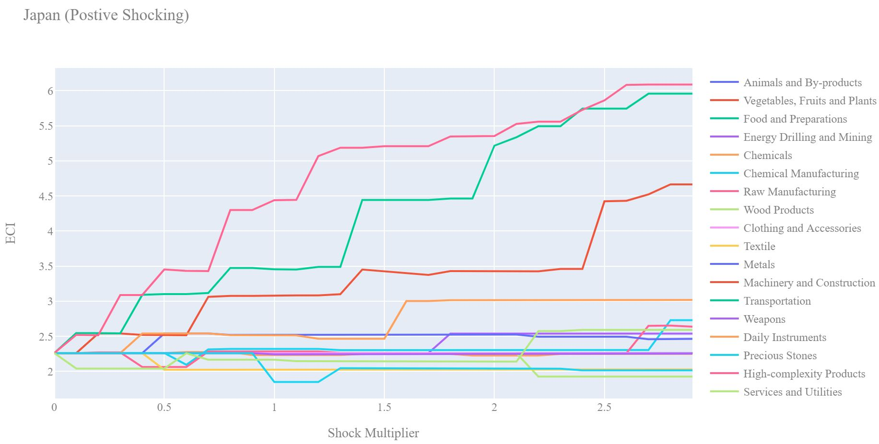
Figure 12: Japan 2018 (Incremental ECI Sensitivity)

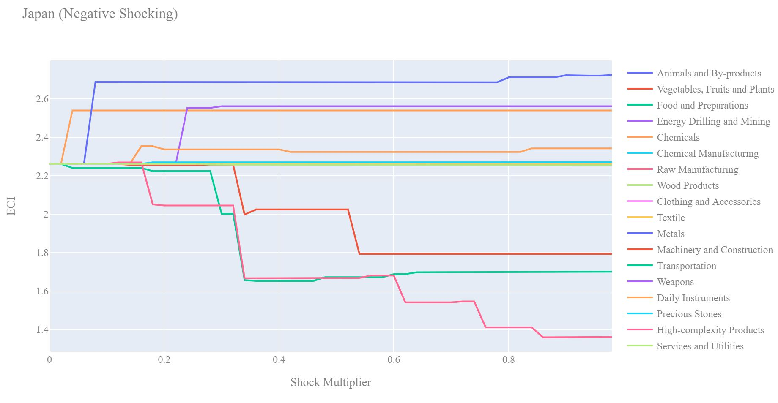
Figure 13: Japan 2018 (Decremental ECI Sensitivity)

Next we consider the 2013 ECI Sensitivity graphs. We see that in the positive shocking case we still have the linear uptrend with High Complexity Products however Transportation and Machinery seem to require much larger increases in export to affect ECI as compared to 2018. This would suggest that Japan has successfully expanded their export in these industries since 2013 or in industries that may give them an advantage in Transportation and Machinery.

In the 2013 negative shocking case, we see that again Japan is very sensitive to decreases in High Complexity Products, Transportation and Machinery. We see that Metals, Weapons, Daily Instrument, Services and Utilities happen to increase ECI when exports in those areas are decreased. As compared to the 2018 chart we see that Japan is no longer as sensitive to Daily Instrument and Services and Utilities suggesting that their economy has begun to rely on other industries to bolster ECI.
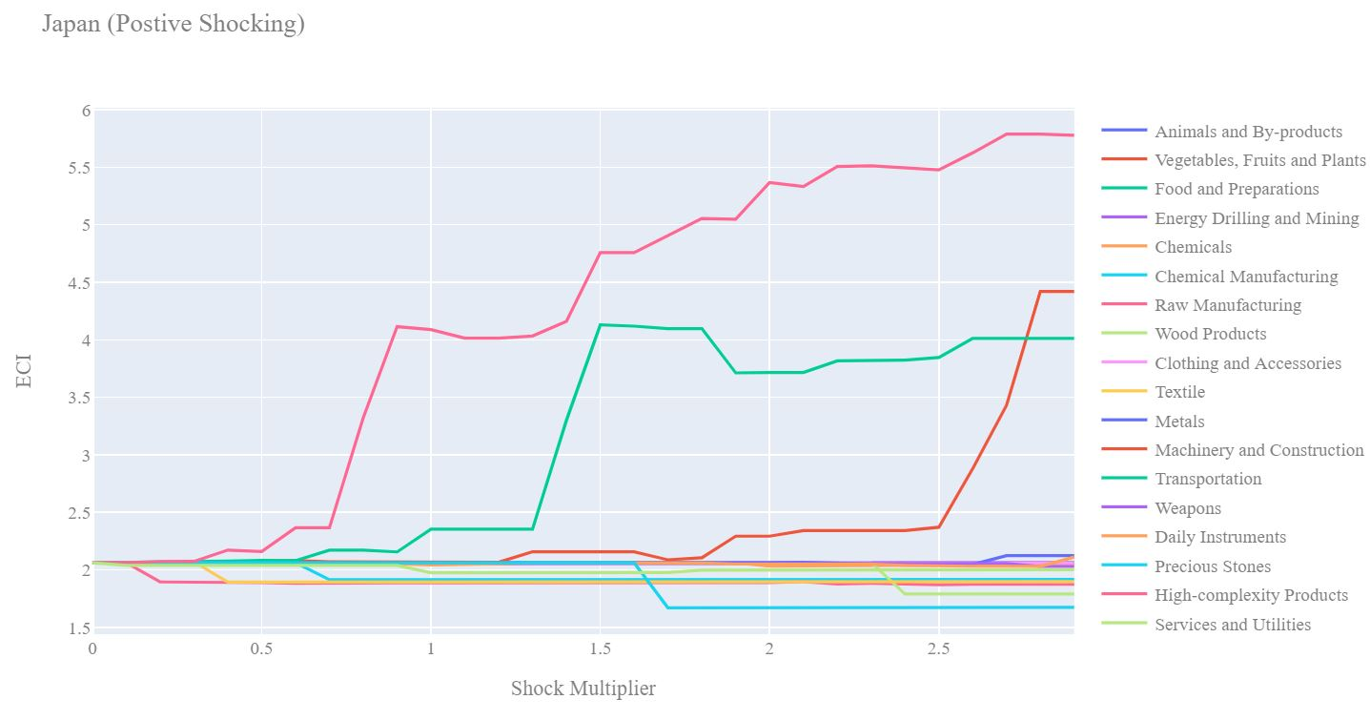
Figure 14: Japan 2013 (Incremental ECI Sensitivity)

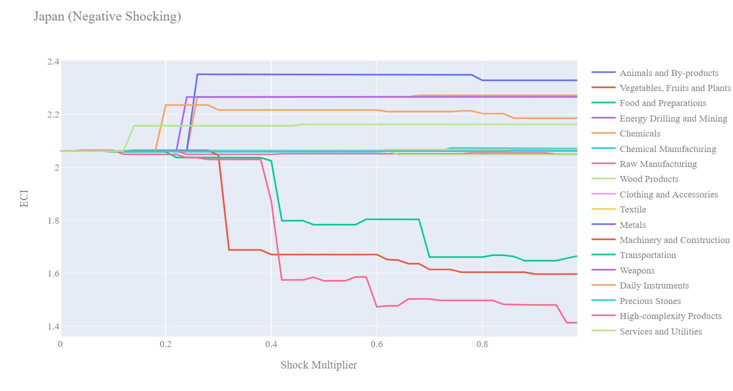
Figure 15: Japan 2013 (Decremental ECI Sensitivity)

Below we see the SDV sensitivity charts for High Complexity Products and Food and Preparations in 2018. Japan’s SDV was shown to be quite sensitive to decrements to export level in High Complexity Products in 2018. This helps explain the decrease in Japan’s ECI over the course of the pandemic, as demand for High Complexity Products decreased globally, thus decreasing the UK’s export of these. In 2018, we see that fairly small increases in export of High Complexity Products makes room for other industries to shift into positive opportunity gain territory. A 50% increase in export leads to 3 new industries that offer positive opportunity gain: Chemicals, Services and Utilities, Textile. Even larger increases in export open up far more industries that offer positive opportunity gain.

Considering the Negative SDV sensitivity chart we observe that as the export of High Complexity Products decreases, industries that were not worth investing begin to shift to the neutral opportunity gain region. Intuitively as High complexity products begin to recede, other industries start to become viable industries to pursue. In 2018, Vegetables, Fruits, and Plants is the only remaining positive industry if a drawdown in High Complexity Products is experienced. Again, this helps explain why Japan’s GDP remained constant despite the change in ECI.


Table 15: Japan High-complexity Products 2018 (Incremental SDV Sensitivity)

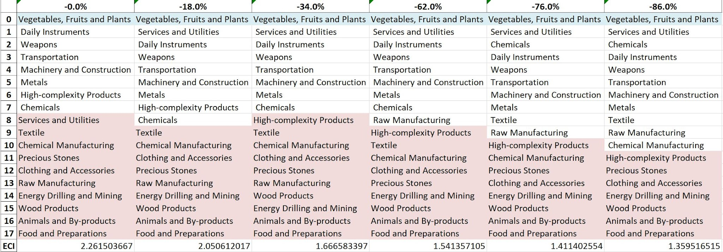
Table 16: Japan High-complexity Products 2018 (Decremental SDV Sensitivity)

Below we see the SDV sensitivity charts for Food and Preparations in 2018. As expected for a developed country, Japan is not very sensitive in both the positive shocking and negative shocking case to Food and Preparations. The country's SDV is largely unaffected by this particular industry.
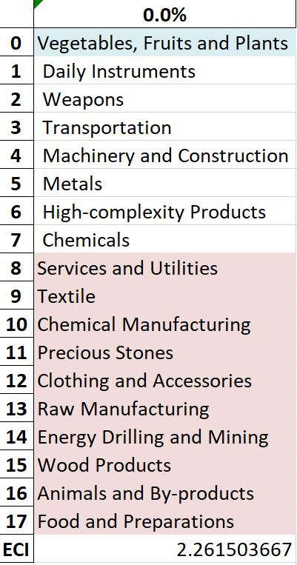
Table 18: Japan Food and Preparations 2018 (Incremental SDV Sensitivity)

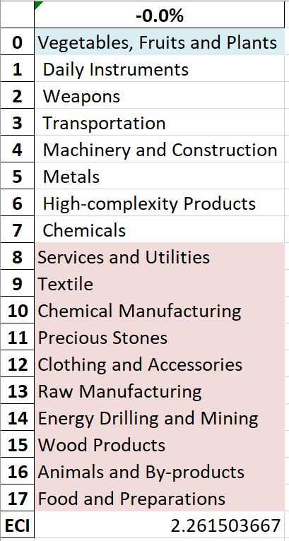

4.4 Contingency Strategy

Decreasing export of each industry in Japan’s 2018 current production space by 60% respectively, we derive the contingency strategy shown below.

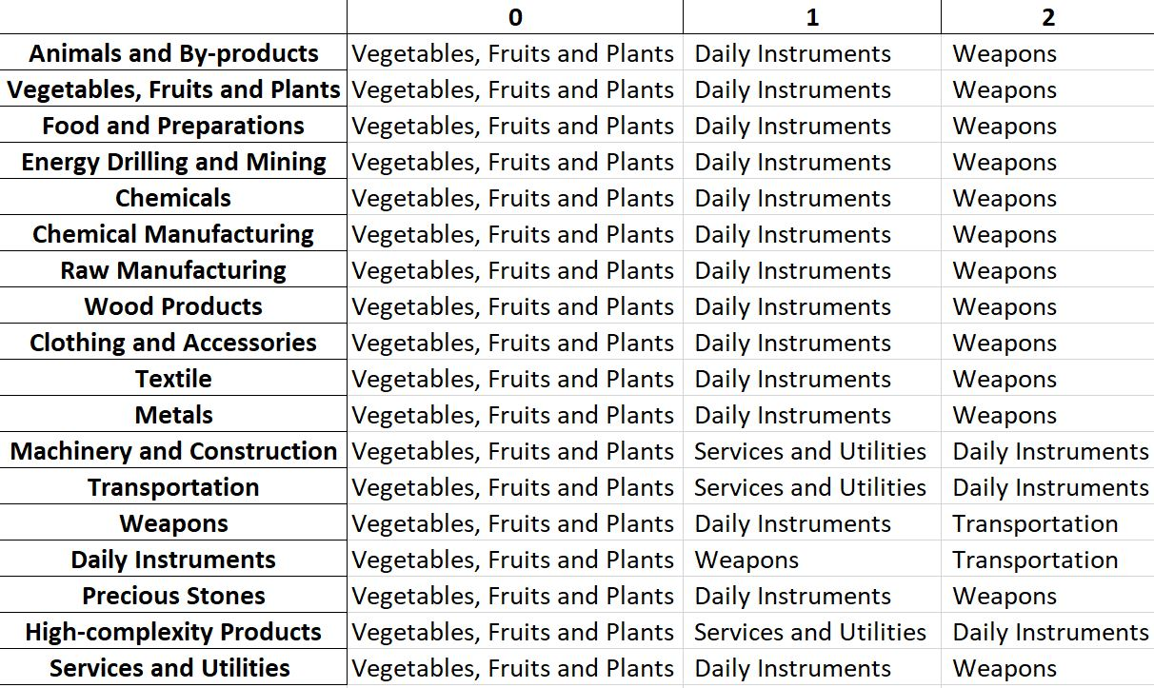
Table 24: Japan Contingency Strategy 2018

Based on Japan’s RID for 2021, we note that the contingency strategy recommended by our algorithm in 2018 is mismatched by Japan’s development strategy over the course of the pandemic. As such, it supports the reasoning behind Japan’s decrease in GDP between 2019 and 2021.

5. Macro-level Predictions

5.1 Structural Optimality Index
Indeed, such choice of prioritization has proven to be a significant factor in deciding the economic outcomes of countries. In order to quantitatively evaluate how effective our development strategies are and how deviations from the suggested developmental path will lead to suboptimal growth results, we define the measure – Structural Optimality Index (SOI) – on a country level as the Adjusted R-Square obtained from regressing the country’s realized industry development over the suggested development strategy. Both strategies are quantified in nature, with the realized development represented by export increase in every major industry group and the suggested development strategy represented by the opportunity gains of developing the corresponding industry groups as calculated in previous sections. The adjusted R-square from the regression thus provides us with a quantified measure of how the development path adopted by the country has fitted with/differed from calculations on a complexity level.

After obtaining this measure for all countries in our database, we further regress countries’ five-year economic growth, which is defined as the percent increase in GDP (USD), over their SOI. Figure 20 illustrates the regression output, which shows a strong positive correlation between countries’ SOI and their five-year GDP growth, significant at the 1% level and achieving an adjusted R² of 4.5%. In other words, the more a country develops as suggested by calculations on a complexity level, the better economic outcomes it achieves.

Table 14: OLS Regression Results
Dep. Variable: GDP | F-Statistic: 5.963
R²: 0.054 | Prob (F-Stat): 0.0163
Adj R²: 0.045 | No. Observations: 106

Figure 20: Regression of Five-year GDP Growth over SOI

5.2 SOI of Japan and Its Implications
Japan, for instance, has a relatively low level of structural optimality as compared with its peers. As the regression in Figure 7 suggests (the orange curve represents export increase and the blue curve stands for opportunity gain of the corresponding industry), Japan demonstrates a moderate level of correlation with the suggested developmental path, having an adjusted R-square of around -4.8% and a 5-year growth rate of 9.0%. This is in direct contrast to emerging economies such as Turkey, where there is a high SOI of around 21.8% and a corresponding 5-year GDP growth of 36.7%, making it one of the fastest developing economies during the period. In sum, Japan’s stagnant economic progress from 2013 to 2018 can be at least partially explained by a mismatched development strategy that demonstrates a considerable level of deviations from our suggested developmental path. Carefully, it is important to consider that the same economic factors that throw off SOI, can make it seem like a more powerful predictor in some cases. Japan’s economy has dealt with many other economic factors, including a declining working population and negative interest rates, that may affect these results. In specific, Japan invested heavily in the High-complexity Products industry, while it should have focused more on industry groups such as Services and Utilities.

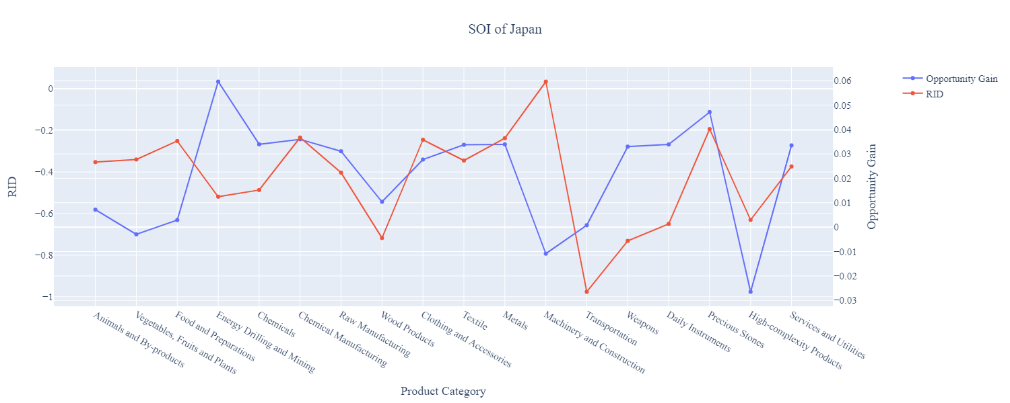

Figure 21: SOI of Japan (2009-2014)
While Japan’s adjusted R-square improved to 0.16% in 2021, it continues to miss opportunity gains in vital industries such as Energy, Drilling, and Mining, Weapons, and Services and Utilities. Instead the figure below shows that Japan overinvested in Transportation, where its RID is significantly higher than its opportunity gain.
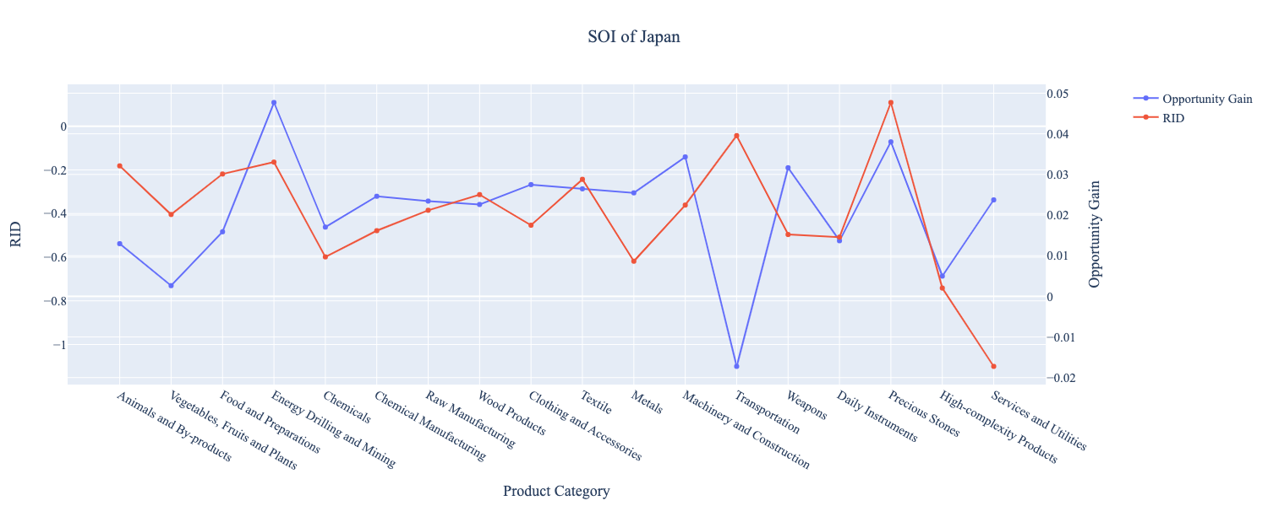
Figure 22: SOI of Japan (2019-2021)

6. Concluding Remarks

In conclusion, Japan has demonstrated a particularly low level of economic growth in terms of GDP during the period from 2013 to 2018, concurrent with a stagnation in economic complexity as compared with other major Asian or developed economies in the world. In 2019-2021, Japan again demonstrated consistently low levels of GDP growth, combined with decreases in ECI as compared with other major developed economies in the world.

The lack of economic progress during the period, we believe, can be partially explained through analysis of the economic and product complexity structure of Japan on the industry group level. The product classification system we adopt allows us to measure the realized industry development for various industry groups and to observe that Japan aggressively invested in Machinery and Construction and Precious Stones industry groups during 2013-2018, while its developed peers and emerging economies around the globe have adopted a slightly more conservative growth path. In 2019-2021, Japan invested in Precious Stones and Transportation, while its peers invested in other industries such as Daily Instruments and Chemicals.

Based on our analysis of the opportunity gain and a sensitivity analysis of major industry groups, Japan can further its gains by developing Chemicals and Wood Products and there is no immediate need of reform because Japan already has a stably high ECI, prior to the pandemic. Given the economic effects of COVID-19, we observe that Japan can further its gains by developing Precious Stones and to focus on greater industry diversity recover from the decrease in ECI. We further note that Japan has a slightly mismatched development strategy that indicates a moderate level of structural optimality on the complexity level, having an adjusted R-square of around 0.16%. Since a significant positive correlation exists between five-year GDP growth and the structural optimality index of an economy as we define and calculate, Japan indeed has a suboptimal growth experience as compared with fast-growing economies both on a regional scale and on a global scale, and has the potential to further its economic gains through industrial structure balancing as suggested in the paper.

References

Hausmann, R., Hidalgo, C., Bustos, S., Coscia, M., Chung, S., Jimenez, J., Simoes, A. and Yıldırım, M. (2007). The Atlas of Economic Complexity. [online] Atlas.cid.harvard.edu. Available at: http://atlas.cid.harvard.edu/.

Balassa, B., “The Purchasing Power Parity Doctrine - A Reapprais- al,” Journal of Political Economy 72, 584-596 (1964).

Feenstra, R.; Lipsey, R.; Deng, H.; Ma, A. & Mo, H. “World Trade Flows: 1962-2000” NBER working paper 11040. National Bureau of Economic Research, Cambridge MA (2005).

United Nations Commodity Trade Statistics Database (http://comtrade.un.org/db/), accessed in August 2019.

The World Economic Forum, “The global competitiveness report,” (various years).

Barro, R. & Lee, J-W. “A New Data Set of Educational Attainment in the World, 1950-2010,” NBER Working Paper No. 1590 (2010).

Kaufmann, D. & Kraay, A. “Governance Indicators: Where Are We, Where Should We Be Going?” Policy Research Working Paper 4370. Washington, DC: World Bank (2008).

Hanushek, E.A. & Woessmann, L. “The Role of Cognitive Skills in Economic Development,” Journal of Economic Literature 46(3), 607- 668 (2008).

